**MODUL PRAKTIKUM SISTEM KENDALI 2**



**DISUSUN OLEH:**

**FADHLAN FIRASYAN 2311010001**

**PROGRAM STUDI D3 MEKATRONIKA**

**POLITEKNIK TAKUMI**

**2024/2025**

Praktikum Sistem Kendali 2

Modul 3 FUNGSI TRANSFER

Nama : Fadhlan Firasyan

NIM : 2311010001

Latihan 3.1

$$T\left(s\right)=\frac{s+3}{s^{2}+2s+4}$$

Solusi Latihan 3.1

|  |
| --- |
| >> num = [1 2];  >> den = [1 2 4];  >> sys = tf(num,den) % Membuat fungsi transfer  sys_zpk = zpk(sys) % Mengubah ke model zpk  sys =    s + 2  -------------  s^2 + 2 s + 4    Continuous-time transfer function.  Model Properties  sys_zpk =    (s+2)  --------------  (s^2 + 2s + 4)    Continuous-time zero/pole/gain model.  Model Properties |

Latihan 3.2

$$T\left(s\right)=\frac{s+4}{{\left(s+1\right)}^{2}\left(s+4\right)}$$

Solusi Latihan 3.2

|  |
| --- |
| >> z = -4;  >> p = [-1-1-4];  >> k = 1;  >> sys = zpk(z,p,k) % membuat model zpk  sys =    (s+4)  -----  (s+6)    Continuous-time zero/pole/gain model.  Model Properties  >> sys_tf = tf(sys) % mengubah ke model fungsi transfer  sys_tf =    s + 4  -----  s + 6    Continuous-time transfer function.  Model Properties |

Latihan 3.3

$$T\left(s\right)=\frac{s+1}{s^{2}+5s+1}$$

Solusi Latihan 3.3

|  |
| --- |
| % Menetapkan variabel s, sebagai variabel dari fungsi transfer  >> s = tf('s');  >> sys = (s+1)/(s^2+5*s+1)  sys =    s + 1  -------------  s^2 + 5 s + 1    Continuous-time transfer function.  Model Properties  % Mengembalikan fungsi transfer dalam bentuk terfaktor  >> s = zpk('s');  >> sys = (s+1)/(s^2+5*s+1)  sys =    (s+1)  --------------------  (s+0.2087) (s+4.791)    Continuous-time zero/pole/gain model.  Model Properties |

Latihan 3.4

$$T\left(s\right)=\frac{(s+1)(s-1)}{{\left(s+5\right)}^{2}(s-7)}$$

Solusi Latihan 3.4

|  |
| --- |
| % Menetapkan variabel s, sebagai variabel dari fungsi transfer  >> s = zpk('s');  >> sys = ((s+2)*(s-1))/(((s+5)^2)*(s-7))  sys =    (s+2) (s-1)  -------------  (s+5)^2 (s-7)    Continuous-time zero/pole/gain model.  Model Properties  % Mengembalikan fungsi transfer dalam bentuk polynomial  >> s = tf('s');  >> sys = ((s+2)*(s-1))/(((s+5)^2)*(s-7))  sys =    s^2 + s - 2  ------------------------  s^3 + 3 s^2 - 45 s - 175    Continuous-time transfer function.  Model Properties |

Latihan 3.5

$$G\left(s\right)=\frac{8s^{2}+1}{s^{3}+3s^{2}+3s+1}$$

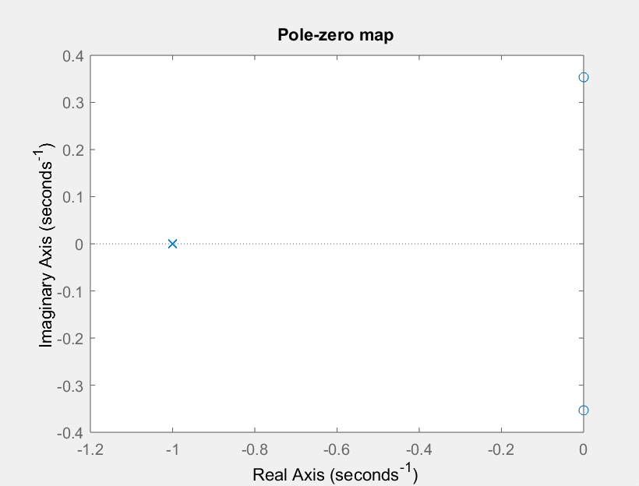Solusi Latihan 3.5

|  |
| --- |
| >> num = [8 0 1];  >> den = [1 3 3 1];  >> pzmap(num,den)  title('pole-zero map'); |

Latihan 3.6

$$G\left(s\right)=\frac{\left(s+1\right)\left(s+2\right)}{\left(s+2i\right)\left(s-2i\right)\left(s+3\right)}$$

Solusi Latihan 3.6

|  |
| --- |
| >> n1 = [1 1];  >> n2 = [1 2];  >> d1 = [1 4*i];  >> d2 = [1 -4*i];  >> d3 = [1 3];  >> num = conv(n1,n2);  >> den = conv(d1,conv(d2,d3));  >> printsys(num,den);  pzmap(num,den);  title('Pole-zero map');    num/den =    s^2 + 3 s + 2  -----------------------  s^3 + 3 s^2 + 16 s + 48 |

